DAILY ONLINE ACTIVITIES SUMMARY

Date: |  | 03-07-2020 |  |  |  |  | Name: | Namratha C
Sem & Sec |  | 8th,A |  |  |  |  | USN: | 4AL16CS056
 |  |  |  | Online Test Summary
Subject |  |  | No test Conducted
Max. Marks |  |  | - |  |  | Score |  |  | -
 |  |  |  | Certification Course Summary
Course |  | Introduction to cyber security
Certificate Provider |  |  |  | Great learner |  | Duration |  |  | 5.5 Hrs
 |  |  |  | academy
 |  |  |  | Coding Challenges

Problem Statement: Python program to convert kilometers to miles

Status: Solved

Uploaded the report in Github | Yes
If yes Repository name
 | Daily_progress
Uploaded the report in slack | Yes

Online Test Details: (Attach the snapshot and briefly write the report for the same)

Certification Course Details: (Attach the snapshot and briefly write the report for the same)

Coding Challenges Details: (Attach the snapshot and briefly write the report for the same)

- Certification Course Details
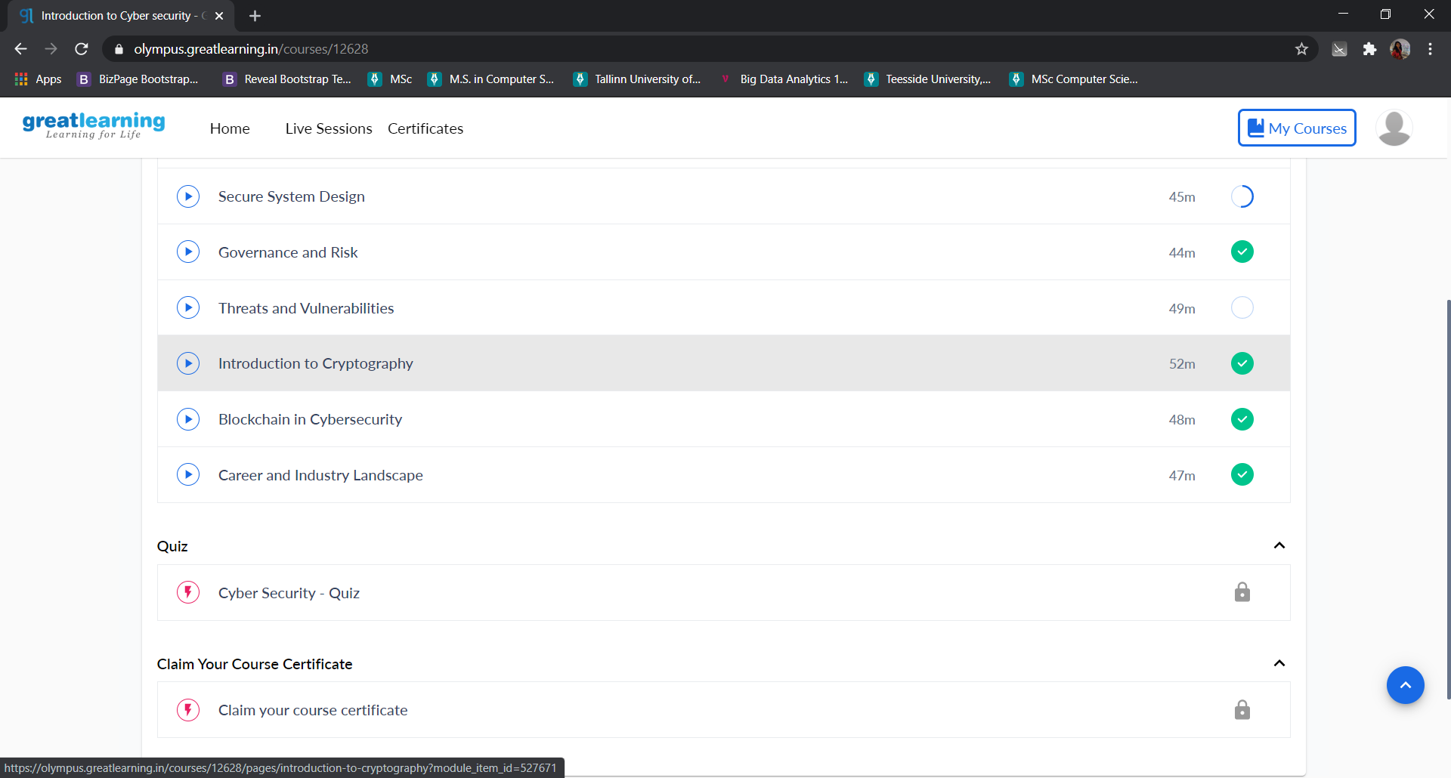

2) Coding Challenges:

# Collect input from the user
kilometers = float(input('How many kilometers?: '))
# conversion factor
conv_fac = 0.621371
# calculate miles
miles = kilometers * conv_fac
print('%0.3f kilometers is equal to %0.3f miles' %(kilometers,miles))

